This text was gotten from this document “20131126 Check bios config on all GreenPlum servers-segments”.

These tunes applies for ProLiant DL380p Gen8

<Section name="1333_MHz_support_for_3DPC_PC3-10600H_HP_SmartMemory" helptext="For Gen8 servers. Allows the enabling/disabling of 1333 MHz support for 3 DIMMs per channel for HP SmartMemory.">Disabled</Section>
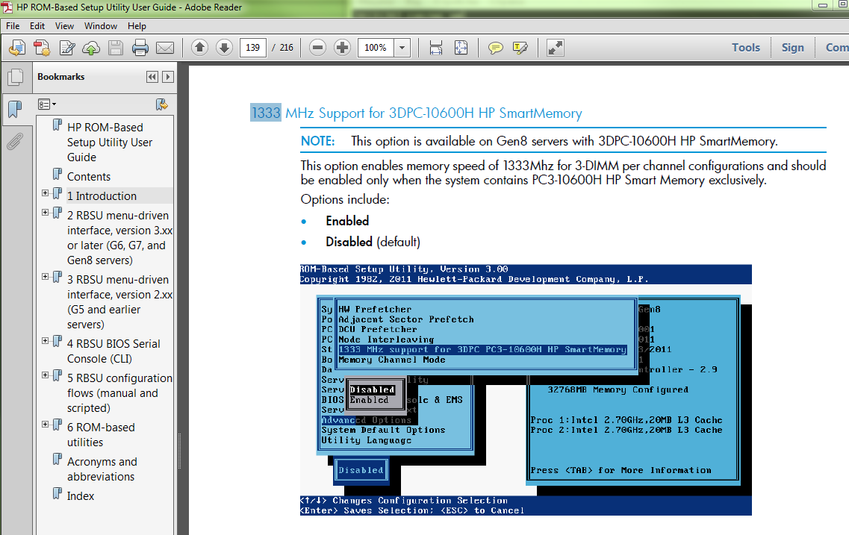

<Section name="QPI_Bandwidth_Optimization_Gen8" helptext="The QPI link between 2 processors has been tuned to provide the best performance for all known applications.">Balanced</Section>

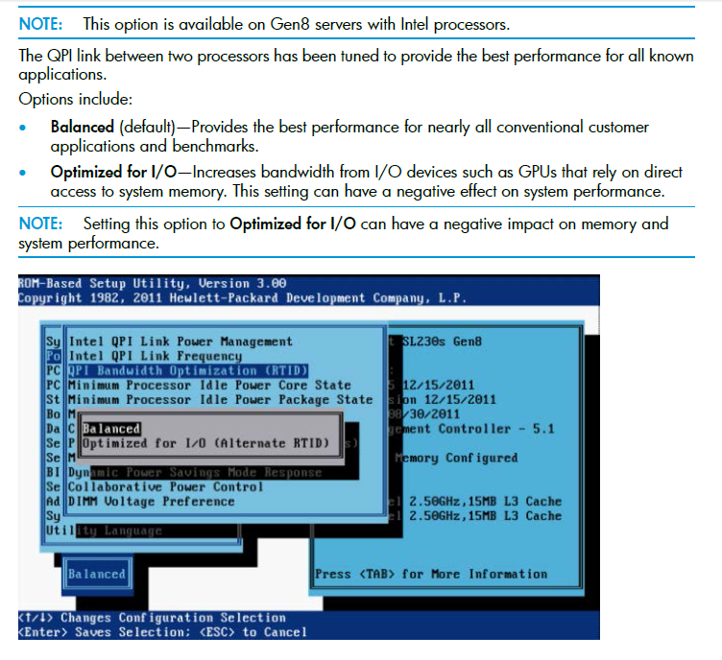

<Section name="HP_Power_Regulator" helptext="Allows tuning of the system power usage">HP_Static_High_Performance_Mode</Section>
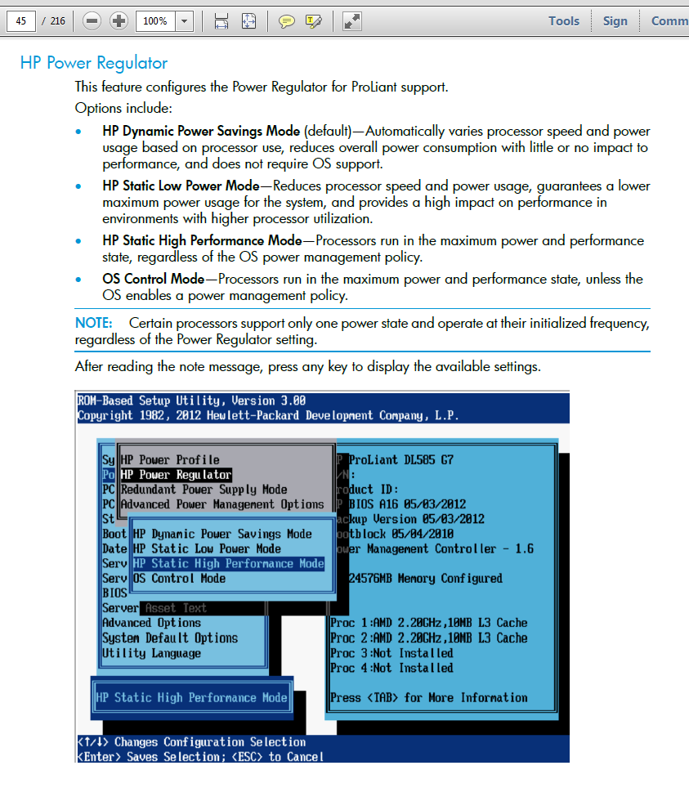

<Section name="HP_Power_Profile" helptext="Selects the level of power versus performance for the system.">Maximum_Performance</Section>
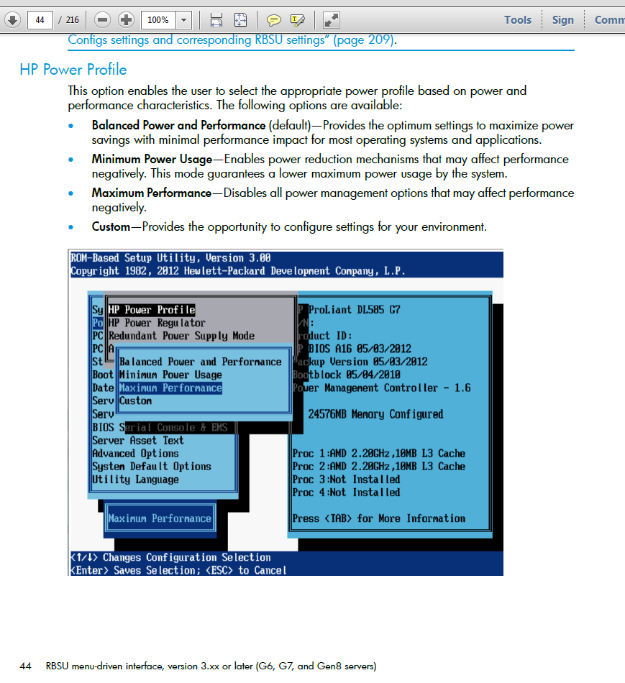

<Section name="Intel_QPI_Link_Power_Management" helptext="Places the Quick Path Interconnect (QPI) links into a low power state to save power.">Disabled</Section>
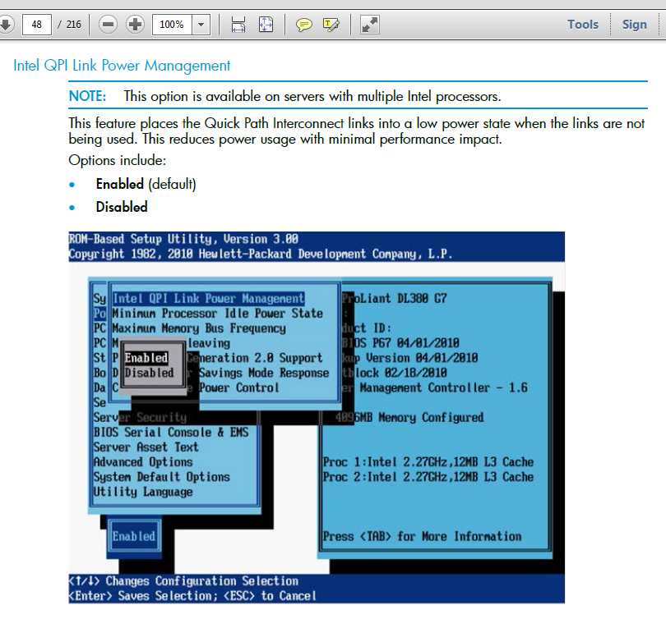

<Section name="Intel_Minimum_Processor_Idle_Power_State" helptext="Selects the lowest idle power state (C-state) the OS will use. The higher the C-state, the lower the power usage. C6 is the lowest power idle state supported. For G6/G7/Gen8 BIOS 05/05/2011 or later, this is the Power Core State. ">No_C-States</Section>
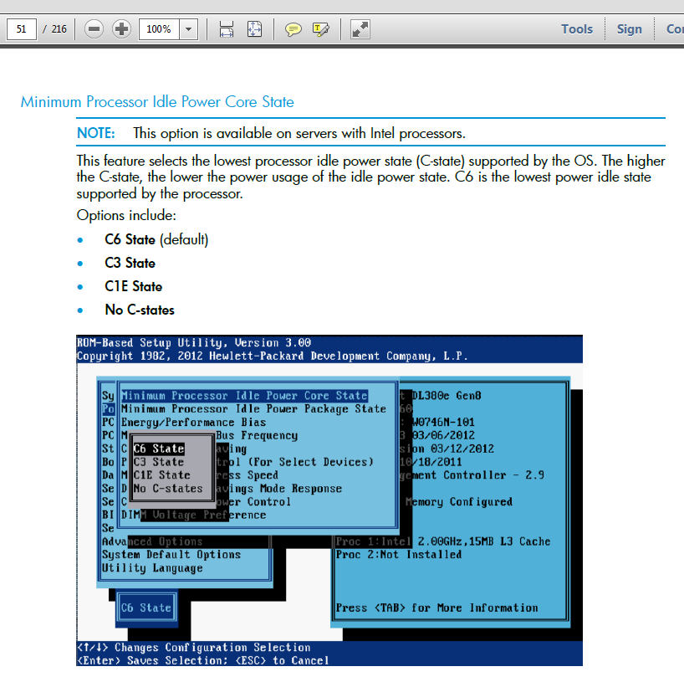

<Section name="Intel_Minimum_Processor_Idle_Power_Package_State" helptext="Selects the lowest idle power package state (C-state). On Gen8 and later servers, Package C3 State corresponds to Package C6(non-retention) State in RBSU.">No_Package_State</Section>
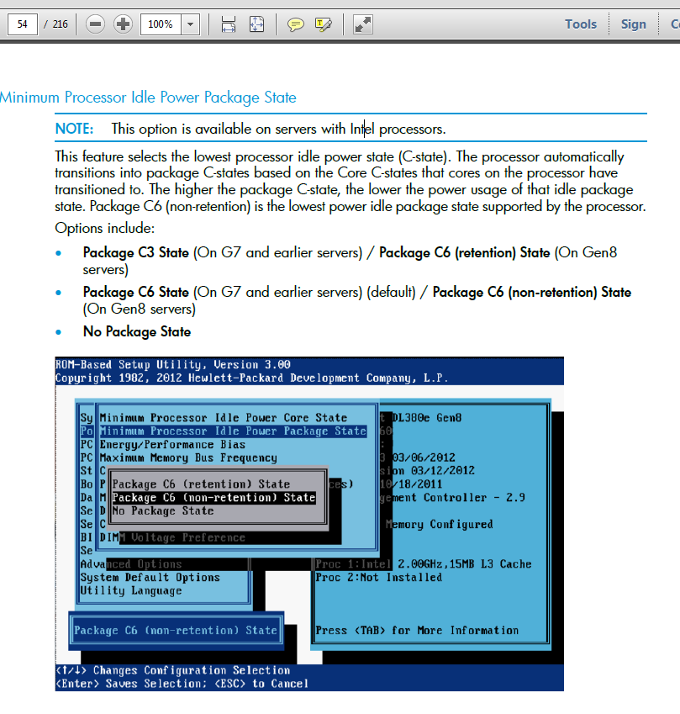

<Section name="Thermal_Configuration" helptext="Selects the fan cooling solution for the system(not for ML350 G6).">Maximum_Cooling</Section>
<Section name="Thermal_Configuration" helptext="Selects the fan cooling solution for the system(not for ML350 G6).">Optimal_Cooling</Section>
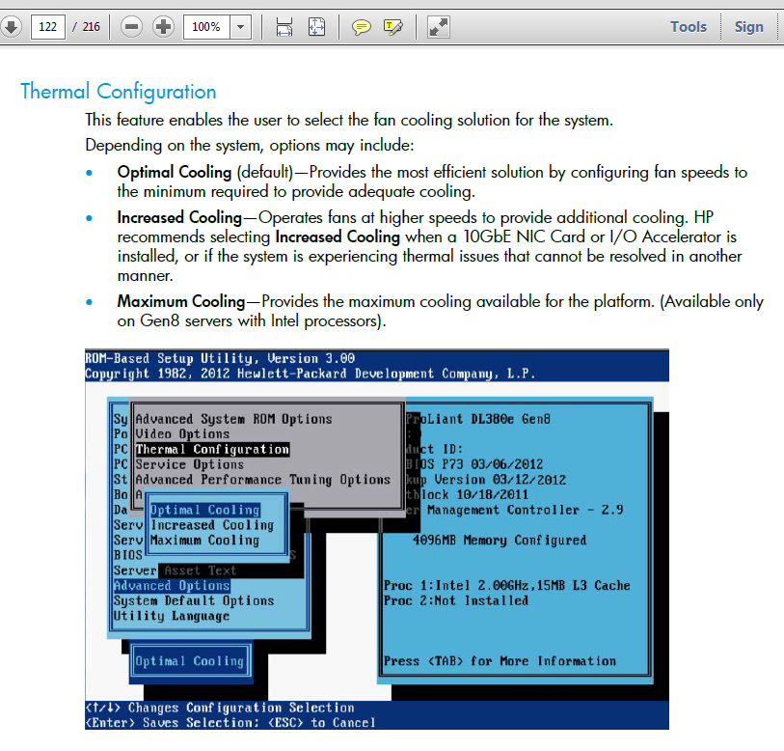

<Section name="Energy_Performance_Bias" helptext="Sets the mode for the Energy/Performance Bias. ">Maximum_Performance</Section>
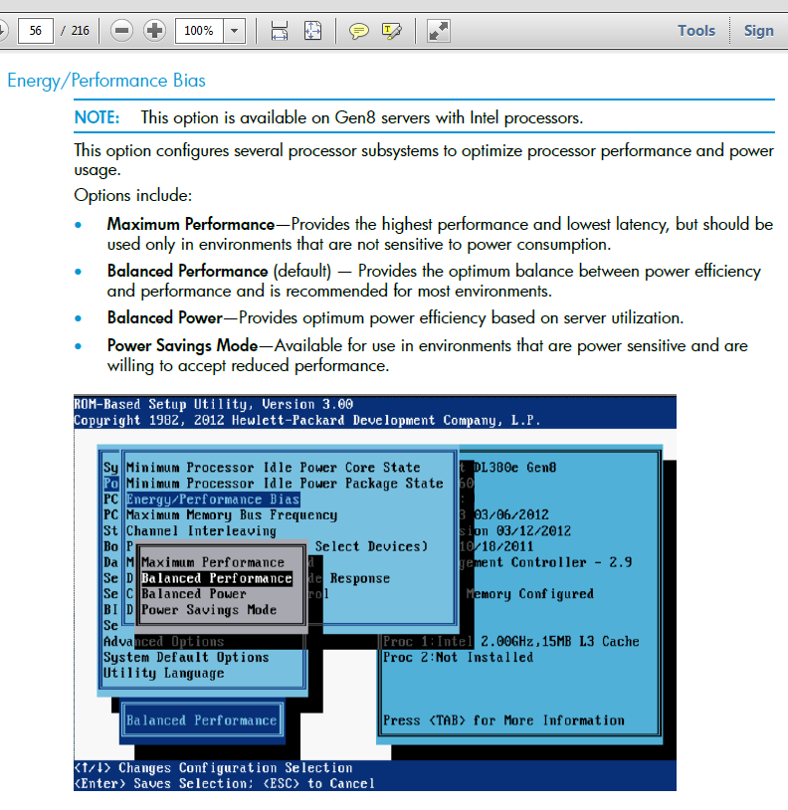

<Section name="Intel_DIMM_Voltage_Preference" helptext=".">Optimized_for_Performance</Section>
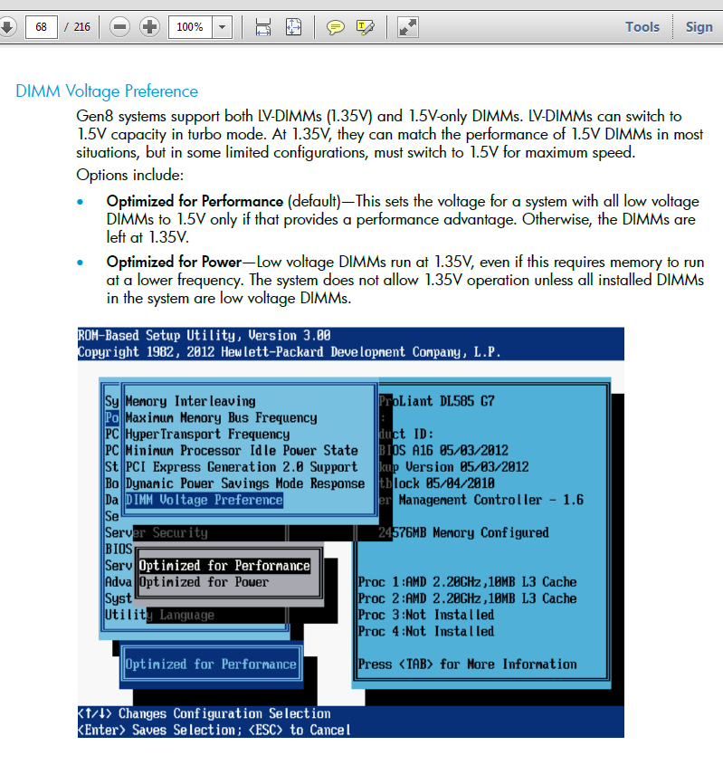

<Section name="Memory_Power_Savings_Mode" helptext=".">Maximum_Performance</Section>
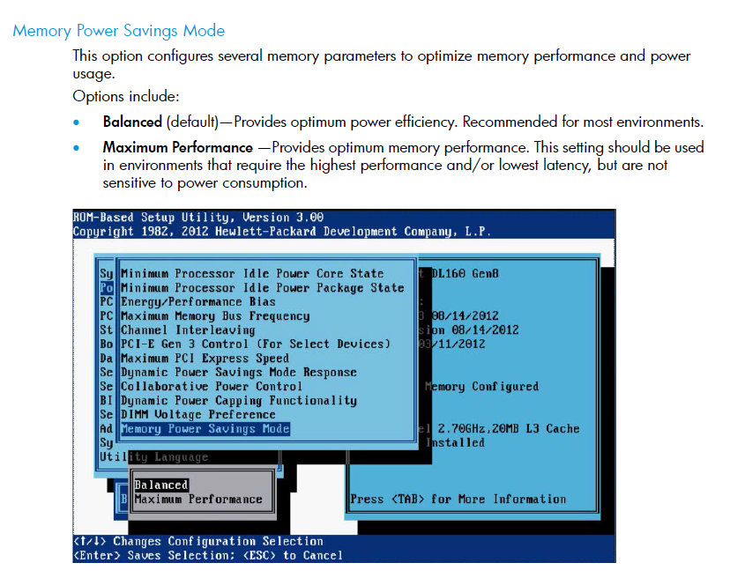

<Section name="Thermal_Shutdown" helptext="Enables shutdown when thermal events occur">Enabled</Section>
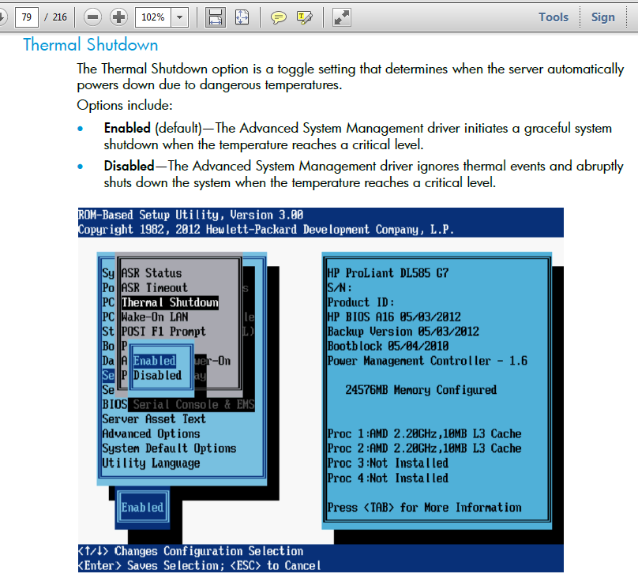

[root@sdw14 20140630-2111]# grep -e "HP_Power_Profile" -e "HP_Power_Regulator" -e "Intel_Minimum_Processor_Idle_Power_State" 20140630-2112.sdw14.conrep.xml
<Section name="HP_Power_Regulator" helptext="Allows tuning of the system power usage">HP_Static_High_Performance_Mode</Section>
<Section name="HP_Power_Profile" helptext="Selects the level of power versus performance for the system.">Maximum_Performance</Section>
<Section name="Intel_Minimum_Processor_Idle_Power_State" helptext="Selects the lowest idle power state (C-state) the OS will use. The higher the C-state, the lower the power usage. C6 is the lowest power idle state supported. For G6/G7/Gen8 BIOS 05/05/2011 or later, this is the Power Core State. ">No_C-States</Section>
[root@sdw14 20140630-2111]#

This text was gotten from this document “20140416 #297909 Unexpected reboot of server hq-msk-gp-prd-sdw13”.

From: Belogrud Sergey Vladimirovich
Sent: Thursday, June 05, 2014 10:53 AM
To: 'Alekhin, Dmitry'; Albutov, Andrey
Cc: Support Desk
Subject: RE: <CASE:4728139851>

Добрый день Дмитрий.

Ошибок от hpsa пока не наблюдается. То есть замена диска позитивно повлияла на их исчезновение.

Содержимое текущих настроек BIOS я выгрузил в файл и проверил значение тех параметров, что вы указали в предыдущем письме.
Они выставлены ровно в те значения, которые Вы рекомендуете.
То есть причина, вероятно, в чём-то другом.

[root@sdw13 20140605-1041]# /opt/hp/scripting/toolkit/utilities/conrep -s -x/opt/hp/scripting/toolkit/utilities/conrep.xml -f$(pwd)/$(date +%Y%m%d-%H%M).$(hostname).conrep.xml
conrep 3.50 - SmartStart Scripting Toolkit Configuration Replication Program
Copyright (c) 2007-2013 Hewlett-Packard Development Company, L.P.

System Type: ProLiant DL380p Gen8
ROM Date : 12/20/2013
ROM Family : P70
Processor Manufacturer : Intel

XML System Configuration : /opt/hp/scripting/toolkit/utilities/conrep.xml
Hardware Configuration : /root/work/20140605-1041/20140605-1042.sdw13.conrep.xml

File contains global platform restrictions
Global Restriction: [minimumconrepversion ] OK

Platform check:
: [ProLiant DL120 G7 ] no match
: [ProLiant ML110 G7 ] no match
: [ProLiant DL3 ] match
: [ProLiant ML3 ] no match
: [ProLiant DL5 ] no match
: [ProLiant ML5 ] no match
: [ProLiant DL7 ] no match
: [ProLiant DL9 ] no match
: [ProLiant BL ] no match
: [ProLiant XW ] no match
: [ProLiant WS ] no match
: [ProLiant SE ] no match
: [ProLiant SL4 ] no match
: [ProLiant SL3 ] no match
: [ProLiant SL2 ] no match
: [ProLiant DL160 Gen8 ] no match
: [ProLiant SL160 Gen8 ] no match
: [ProLiant SL140 ] no match
: [ProLiant WS460c Gen8 WS Blade] no match
: [ProLiant MicroServer Gen8] no match
: [StoreEasy ] no match
: [ProLiant ML10 ] no match

Saving configuration data to /root/work/20140605-1041/20140605-1042.sdw13.conrep.xml.

CONREP Return code: 0
[root@sdw13 20140605-1041]#

[root@sdw13 20140605-1041]# grep -e "HP_Power_Profile" -e "HP_Power_Regulator" -e "Intel_Minimum_Processor_Idle_Power_State" 20140605-1042.sdw13.conrep.xml
<Section name="HP_Power_Regulator" helptext="Allows tuning of the system power usage">HP_Static_High_Performance_Mode</Section>
<Section name="HP_Power_Profile" helptext="Selects the level of power versus performance for the system.">Maximum_Performance</Section>
<Section name="Intel_Minimum_Processor_Idle_Power_State" helptext="Selects the lowest idle power state (C-state) the OS will use. The higher the C-state, the lower the power usage. C6 is the lowest power idle state supported. For G6/G7/Gen8 BIOS 05/05/2011 or later, this is the Power Core State. ">No_C-States</Section>
[root@sdw13 20140605-1041]#

From: Alekhin, Dmitry [mailto:dmitry.alekhin@hp.com]
Sent: Wednesday, June 04, 2014 7:22 PM
To: Belogrud Sergey Vladimirovich; Albutov, Andrey
Cc: Support Desk; Aleksandrov Aleksey Valerievich; Chernyh Aleksandr Vladimirovich; Leonov Aleksey Vladimirovich; Terentev Aleksey; Zbiranik Evgeniy Aleksandrovich; Kartsev Konstantin; Novikov Matvey Sergeevich; Polyakov Valeriy; Ryabov Aleksey; Sotnichenko Sergey; Varakuta Sergey
Subject: RE: <CASE:4728139851>

Сергей, Большое спасибо за информацию.
Я надеюсь, что ошибки перестанут появляться.

Я получил ответ от L2.

В данном случае, наличие ошибок MCE обусловлено настройками энергосбережения в RBSU.

Рекомендуется выполнить следующие операции по настройке:

(2) Make following changes to RBSU setting:
>> Power Management Options
> HP power profile: Maximum performance.
> HP Power Regulator: HP Static High Performance Mode.
> Advanced Power Management Options > Minimum Processor Idle Power Core State: No C-states

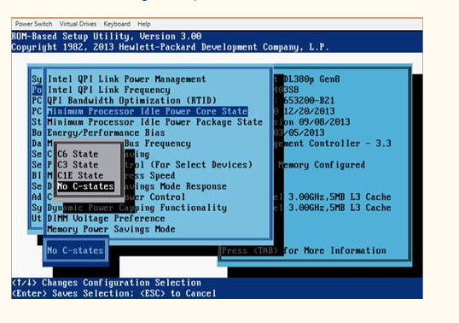

И проверить лог mce на наличие записей, они должны перестать появляться.

Best Regards,
Dmitry Alekhin
RSAA
+79104995717

This text was gotten from this document “20140603 Writing BIOS configuration to new server motherboard (GreenPlum)”.

See differences between right BIOS config and current BIOS config.
[root@sdw5 20140603-1230]# diff -Nuar 20140603-1322.sdw5.conrep.xml 20140603-1229.sdw6.conrep.xml
--- 20140603-1322.sdw5.conrep.xml 2014-06-03 13:46:58.957613584 +0400
+++ 20140603-1229.sdw6.conrep.xml 2014-06-03 13:46:36.701608098 +0400
@@ -1,9 +1,6 @@
<?xml version="1.0" encoding="UTF-8"?>
<!--generated by conrep version 3.50-->
<Conrep version="3.50" originating_platform="ProLiant DL380p Gen8" originating_family="P70" originating_romdate="12/20/2013" originating_processor_manufacturer="Intel">
- <Section name="IMD_ServerName" helptext="LCD Display name for this server">
- <Line0>WIN-FDNX008S3DA</Line0>
- </Section>
<Section name="IPL_Order" helptext="Current Initial ProgramLoad device boot order.">
<Index0>00 </Index0>
<Index1>01 </Index1>
@@ -35,10 +32,6 @@
<Slot1>00 </Slot1>
<BusDev1>00 fa </BusDev1>
<Rest1>41 </Rest1>
- <Id2>10 3c 33 51 </Id2>
- <Slot2>02 </Slot2>
- <BusDev2>07 00 </BusDev2>
- <Rest2>41 </Rest2>
</Section>
<Section name="Language" helptext="Defines current language identifier">ENGUSAus </Section>
<Section name="System_WOL" helptext="System Wake On Lan Capabilities.">Enabled</Section>
@@ -72,7 +65,7 @@
<Section name="EMS_Console" helptext="Used to select the port for the EMS console">Disabled</Section>
<Section name="BIOS_Interface_Mode" helptext="BIOS console communications settings">Auto Mode</Section>
<Section name="Virtual_Install_Disk" helptext="Controls the Virtual Install Disk. The Virtual Install Disk may contain drivers specific to this server that an OS may use during installation..">Disabled</Section>
- <Section name="HP_Power_Regulator" helptext="Allows tuning of the system power usage">HP_Dynamic_Power_Savings_Mode</Section>
+ <Section name="HP_Power_Regulator" helptext="Allows tuning of the system power usage">HP_Static_High_Performance_Mode</Section>
<Section name="HW_Prefetch" helptext="System performance tuning entry">Enabled</Section>
<Section name="Adjacent_Sector_Prefetch" helptext="System performance tuning entry">Enabled</Section>
<Section name="ATA_Drive_Write_Cache" helptext="Enables the write cache on attached ATA disks">Disabled</Section>
@@ -117,11 +110,11 @@
<Section name="Intel_Processor_Core_Disable" helptext="Allows disabling of processor cores using Intel's Core Multi-Processing(CMP) technology.">All_Cores_Enabled</Section>
<Section name="Intel_Processor_Turbo_Mode" helptext="Allows Intel processors to transition to a higher frequency than its rated speed if the processor has available headroom and is within temperature specification.">Enabled</Section>
<Section name="Intel_VT-d2" helptext="When enabled, a Virtual Machine Manager supporting this feature can utilize hardware capabilities provided by Intel's Virtualization Technology for Directed I/O.">Enabled</Section>
- <Section name="HP_Power_Profile" helptext="Selects the level of power versus performance for the system.">Balanced</Section>
- <Section name="Intel_QPI_Link_Power_Management" helptext="Places the Quick Path Interconnect (QPI) links into a low power state to save power.">Enabled</Section>
+ <Section name="HP_Power_Profile" helptext="Selects the level of power versus performance for the system.">Maximum_Performance</Section>
+ <Section name="Intel_QPI_Link_Power_Management" helptext="Places the Quick Path Interconnect (QPI) links into a low power state to save power.">Disabled</Section>
<Section name="Intel_QPI_Link_Frequency" helptext="This option allows the user to set the QPI Link frequency to a lower speed. Running at a lower frequency may reduce power consumption but may also impact system performance.">Auto</Section>
- <Section name="Intel_Minimum_Processor_Idle_Power_State" helptext="Selects the lowest idle power state (C-state) the OS will use. The higher the C-state, the lower the power usage. C6 is the lowest power idle state supported. For G6/G7/Gen8 BIOS 05/05/2011 or later, this is the Power Core State. ">C6_State</Section>
- <Section name="Intel_Minimum_Processor_Idle_Power_Package_State" helptext="Selects the lowest idle power package state (C-state). On Gen8 and later servers, Package C3 State corresponds to Package C6(non-retention) State in RBSU.">Package C3 State</Section>
+ <Section name="Intel_Minimum_Processor_Idle_Power_State" helptext="Selects the lowest idle power state (C-state) the OS will use. The higher the C-state, the lower the power usage. C6 is the lowest power idle state supported. For G6/G7/Gen8 BIOS 05/05/2011 or later, this is the Power Core State. ">No_C-States</Section>
+ <Section name="Intel_Minimum_Processor_Idle_Power_Package_State" helptext="Selects the lowest idle power package state (C-state). On Gen8 and later servers, Package C3 State corresponds to Package C6(non-retention) State in RBSU.">No_Package_State</Section>
<Section name="Maximum_Memory_Bus_Frequency" helptext="Configures memory system to run memory at a lower maximum speed than what is supported by the installed processor and DIMM configuration. Setting to Auto configures max speed supported.">Auto</Section>
<Section name="Memory_Interleaving" helptext="Modifies the level of interleaving for which the memory system will be configured. Typically, higher levels of memory interleaving result in maximum performance, but reducing interleaving level may result in power savings.">Full_Interleaving</Section>
<Section name="Intel_PCI_Express_Generation_20_Support" helptext="For Gen8 servers, this is the same as Intel Maximum PCI Express Speed. Force_PCI-E_Generation_2 is the same as Maximum Supported on Gen8.">Force_PCI-E_Generation_2</Section>
@@ -181,11 +174,11 @@
<Section name="Intel_PCI_Express_Gen3_Slot_15_Control" helptext="Allows enabling/disabling PCI-E Gen 3.0 Slot 15 on Intel based Gen8 or later servers.">Enabled</Section>
<Section name="Intel_PCI_Express_Gen3_Slot_16_Control" helptext="Allows enabling/disabling PCI-E Gen 3.0 Slot 16 on Intel based Gen8 or later servers.">Enabled</Section>
<Section name="Intel_F11_Boot_Menu_Prompt" helptext="This option allows the disabling of the POST One Time Boot F11 Prompt on Gen8 Servers. ">Enabled</Section>
- <Section name="Energy_Performance_Bias" helptext="Sets the mode for the Energy/Performance Bias. ">Balanced_Performance</Section>
+ <Section name="Energy_Performance_Bias" helptext="Sets the mode for the Energy/Performance Bias. ">Maximum_Performance</Section>
<Section name="1333_MHz_support_for_3DPC_PC3-10600H_HP_SmartMemory" helptext="For Gen8 servers. Allows the enabling/disabling of 1333 MHz support for 3 DIMMs per channel for HP SmartMemory.">Disabled</Section>
<Section name="System_Locality_Information_Table_G7" helptext="This ACPI SLIT (System Locality Information Table) describes the relative access times between processors, memory subsystems, and I/O subsystems.">Disabled</Section>
<Section name="System_Locality_Information_Table_Gen8" helptext="This ACPI SLIT (System Locality Information Table) describes the relative access times between processors, memory subsystems, and I/O subsystems.">Disabled</Section>
- <Section name="Intel_DIMM_Voltage_Preference" helptext=".">Optimized_for_Power</Section>
+ <Section name="Intel_DIMM_Voltage_Preference" helptext=".">Optimized_for_Performance</Section>
<Section name="Intel_Memory_Channel_Mode_Gen8" helptext="Combined Channel Mode provides maximum data protection by allowing multiple-bit memory errors to be corrected in certain instances not possible in normal Advanced ECC Modes.">Independent_Channel_Mode</Section>
<Section name="Dynamic_Power_Capping_Functionality" helptext="This option allows the user to disable the System ROM Power Calibration feature that is executed during the boot process. When disabled, the user can expect faster boot times.">Enabled</Section>
<Section name="SR-IOV" helptext="This option provides the capability to enable or disable SR-IOV(Single Root I/O Virtualization). ">Disabled</Section>
[root@sdw5 20140603-1230]#

Save differences to file.
[root@sdw5 20140603-1230]# diff -Nuar 20140603-1322.sdw5.conrep.xml 20140603-1229.sdw6.conrep.xml > patch.sdw5.txt
[root@sdw5 20140603-1230]#

Edit file - delete couple of headers differences.
And see what we have after it.
[root@sdw5 20140603-1230]# cat patch.sdw5.txt
--- 20140603-1322.sdw5.conrep.xml 2014-06-03 13:46:58.957613584 +0400
+++ 20140603-1229.sdw6.conrep.xml 2014-06-03 13:46:36.701608098 +0400
@@ -72,7 +65,7 @@
<Section name="EMS_Console" helptext="Used to select the port for the EMS console">Disabled</Section>
<Section name="BIOS_Interface_Mode" helptext="BIOS console communications settings">Auto Mode</Section>
<Section name="Virtual_Install_Disk" helptext="Controls the Virtual Install Disk. The Virtual Install Disk may contain drivers specific to this server that an OS may use during installation..">Disabled</Section>
- <Section name="HP_Power_Regulator" helptext="Allows tuning of the system power usage">HP_Dynamic_Power_Savings_Mode</Section>
+ <Section name="HP_Power_Regulator" helptext="Allows tuning of the system power usage">HP_Static_High_Performance_Mode</Section>
<Section name="HW_Prefetch" helptext="System performance tuning entry">Enabled</Section>
<Section name="Adjacent_Sector_Prefetch" helptext="System performance tuning entry">Enabled</Section>
<Section name="ATA_Drive_Write_Cache" helptext="Enables the write cache on attached ATA disks">Disabled</Section>
@@ -117,11 +110,11 @@
<Section name="Intel_Processor_Core_Disable" helptext="Allows disabling of processor cores using Intel's Core Multi-Processing(CMP) technology.">All_Cores_Enabled</Section>
<Section name="Intel_Processor_Turbo_Mode" helptext="Allows Intel processors to transition to a higher frequency than its rated speed if the processor has available headroom and is within temperature specification.">Enabled</Section>
<Section name="Intel_VT-d2" helptext="When enabled, a Virtual Machine Manager supporting this feature can utilize hardware capabilities provided by Intel's Virtualization Technology for Directed I/O.">Enabled</Section>
- <Section name="HP_Power_Profile" helptext="Selects the level of power versus performance for the system.">Balanced</Section>
- <Section name="Intel_QPI_Link_Power_Management" helptext="Places the Quick Path Interconnect (QPI) links into a low power state to save power.">Enabled</Section>
+ <Section name="HP_Power_Profile" helptext="Selects the level of power versus performance for the system.">Maximum_Performance</Section>
+ <Section name="Intel_QPI_Link_Power_Management" helptext="Places the Quick Path Interconnect (QPI) links into a low power state to save power.">Disabled</Section>
<Section name="Intel_QPI_Link_Frequency" helptext="This option allows the user to set the QPI Link frequency to a lower speed. Running at a lower frequency may reduce power consumption but may also impact system performance.">Auto</Section>
- <Section name="Intel_Minimum_Processor_Idle_Power_State" helptext="Selects the lowest idle power state (C-state) the OS will use. The higher the C-state, the lower the power usage. C6 is the lowest power idle state supported. For G6/G7/Gen8 BIOS 05/05/2011 or later, this is the Power Core State. ">C6_State</Section>
- <Section name="Intel_Minimum_Processor_Idle_Power_Package_State" helptext="Selects the lowest idle power package state (C-state). On Gen8 and later servers, Package C3 State corresponds to Package C6(non-retention) State in RBSU.">Package C3 State</Section>
+ <Section name="Intel_Minimum_Processor_Idle_Power_State" helptext="Selects the lowest idle power state (C-state) the OS will use. The higher the C-state, the lower the power usage. C6 is the lowest power idle state supported. For G6/G7/Gen8 BIOS 05/05/2011 or later, this is the Power Core State. ">No_C-States</Section>
+ <Section name="Intel_Minimum_Processor_Idle_Power_Package_State" helptext="Selects the lowest idle power package state (C-state). On Gen8 and later servers, Package C3 State corresponds to Package C6(non-retention) State in RBSU.">No_Package_State</Section>
<Section name="Maximum_Memory_Bus_Frequency" helptext="Configures memory system to run memory at a lower maximum speed than what is supported by the installed processor and DIMM configuration. Setting to Auto configures max speed supported.">Auto</Section>
<Section name="Memory_Interleaving" helptext="Modifies the level of interleaving for which the memory system will be configured. Typically, higher levels of memory interleaving result in maximum performance, but reducing interleaving level may result in power savings.">Full_Interleaving</Section>
<Section name="Intel_PCI_Express_Generation_20_Support" helptext="For Gen8 servers, this is the same as Intel Maximum PCI Express Speed. Force_PCI-E_Generation_2 is the same as Maximum Supported on Gen8.">Force_PCI-E_Generation_2</Section>
@@ -181,11 +174,11 @@
<Section name="Intel_PCI_Express_Gen3_Slot_15_Control" helptext="Allows enabling/disabling PCI-E Gen 3.0 Slot 15 on Intel based Gen8 or later servers.">Enabled</Section>
<Section name="Intel_PCI_Express_Gen3_Slot_16_Control" helptext="Allows enabling/disabling PCI-E Gen 3.0 Slot 16 on Intel based Gen8 or later servers.">Enabled</Section>
<Section name="Intel_F11_Boot_Menu_Prompt" helptext="This option allows the disabling of the POST One Time Boot F11 Prompt on Gen8 Servers. ">Enabled</Section>
- <Section name="Energy_Performance_Bias" helptext="Sets the mode for the Energy/Performance Bias. ">Balanced_Performance</Section>
+ <Section name="Energy_Performance_Bias" helptext="Sets the mode for the Energy/Performance Bias. ">Maximum_Performance</Section>
<Section name="1333_MHz_support_for_3DPC_PC3-10600H_HP_SmartMemory" helptext="For Gen8 servers. Allows the enabling/disabling of 1333 MHz support for 3 DIMMs per channel for HP SmartMemory.">Disabled</Section>
<Section name="System_Locality_Information_Table_G7" helptext="This ACPI SLIT (System Locality Information Table) describes the relative access times between processors, memory subsystems, and I/O subsystems.">Disabled</Section>
<Section name="System_Locality_Information_Table_Gen8" helptext="This ACPI SLIT (System Locality Information Table) describes the relative access times between processors, memory subsystems, and I/O subsystems.">Disabled</Section>
- <Section name="Intel_DIMM_Voltage_Preference" helptext=".">Optimized_for_Power</Section>
+ <Section name="Intel_DIMM_Voltage_Preference" helptext=".">Optimized_for_Performance</Section>
<Section name="Intel_Memory_Channel_Mode_Gen8" helptext="Combined Channel Mode provides maximum data protection by allowing multiple-bit memory errors to be corrected in certain instances not possible in normal Advanced ECC Modes.">Independent_Channel_Mode</Section>
<Section name="Dynamic_Power_Capping_Functionality" helptext="This option allows the user to disable the System ROM Power Calibration feature that is executed during the boot process. When disabled, the user can expect faster boot times.">Enabled</Section>
<Section name="SR-IOV" helptext="This option provides the capability to enable or disable SR-IOV(Single Root I/O Virtualization). ">Disabled</Section>
[root@sdw5 20140603-1230]#

Just see what about cooling configuration. It’s not necessery.
[root@sdw5 20140603-1230]# grep "Thermal_Configuration" 20140603-1322.sdw5.conrep.xml
<Section name="Thermal_Configuration" helptext="Selects the fan cooling solution for the system(not for ML350 G6).">Optimal_Cooling</Section>

